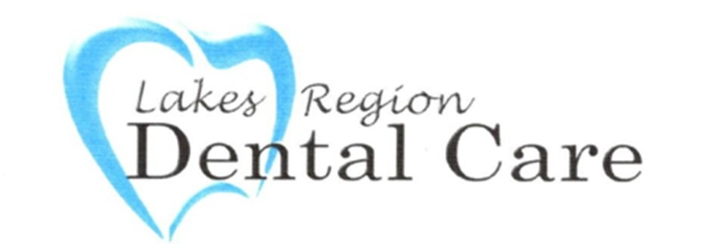

**Lakes Region Dental Care Terms of Service for Text Message Communications**

By using Lakes Region Dental Care’s services, including signing up for text message communications, you expressly consent to the collection, use, and sharing of your personal information as outlined in our Privacy Policy. You acknowledge that you have read, understood, and agree to our Terms of Service and Privacy Policy, including the terms related to data collection, communication, and security.

You further consent to receive text messages from Lakes Region Dental Care, including transactional and promotional messages. These messages may include appointment reminders, treatment information, promotional offers, and other communications related to our services.

You may choose to stop receiving promotional text messages from Lakes Region Dental Care at any time. To opt out, simply reply to any text message you receive from us with the word "STOP" or "UNSUBSCRIBE." Once we receive your opt-out request, we will promptly remove your number from our promotional messaging list. Please note that opting out of promotional messages will not affect your ability to receive important service-related communications, such as appointment reminders or billing updates.

Your continued use of our services constitutes your ongoing consent to these terms.

For any questions or concerns regarding our Terms of Service or Privacy Policy, please contact us at 603-524-8250.